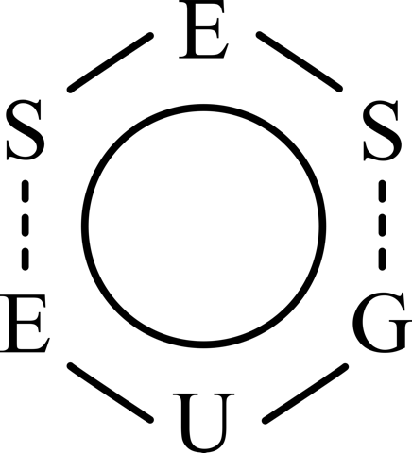

Summer School in High Energy Processing Ultrasound & Microwave Technologies 26-28 June 2019

Registration Form
Please complete this application form, and save it as the MS Word file (yourlastname.doc)
Send the completed form by 31.03.2019, via email to wkas@chemia.pk.edu.pl , azaba@chemia.pk.edu.pl

Personal details
Degree/Title |  |  | First Name |  |  | Surname
Institution details:
Institution |  |  |  |  | Department
Address
Postcode . |  |  |  |  | City
Country |  |  |  |  | Telephone
Email |  |  |  |  | Fax
Would you like to receive an invoice:
Invoice details:
Name/ Institution
Address
Postcode . |  |  |  |  | City
Country |  |  |  |  | VAT No.
Delivery address:
Name/ Institution
Address
Postcode . |  |  |  |  | City
Country |  |  |  |  | Telephone
I agree to receive an invoice without a signature and I consent that my personal data may be processed by the Summer School organizer to enhance the conference organization. I am aware of my right to inspect the data and to correct it. The organizers assure that your data shall not be made available to other companies without prior notification and your consent. The data is protected under the Data Protection Act (Dz. U. Nr 133/97, pos. 883).

Details of payment:
Registration fee*
TOTAL (EURO/PLN)**
* Please write down the sum of registration fee; ** summarized and mark currency
* For cancellations made by 30 April, 2019, your registration fee will be refunded less a 50 Euro cancellation fee. No refunds will be given for cancellations made after 30 April, 2019.

Signature: Date:

Organizer/Beneficiary: Conference Coordinators:
Cracow University of Technology Wiktor Kasprzyk – (registration & payments)
ul. Warszawska 24 Adam Żaba – (registration & payments)
31-155 Kraków

Bank information:
Alior Bank Spółka Akcyjna, ul. Łopuszańska 38D, 02-232 Warszawa
for EURO 40 2490 0005 0000 4600 3419 4146
for PLN 09 2490 0005 0000 4600 1012 1826
SWIFT code: ALBPPLPW
IBAN: PL
Pls. indicate on the transfer slip:
"AMPERE 2019 – Name and surname"

More information at:
http://www.school2019.chemia.pk.edu.pl/

